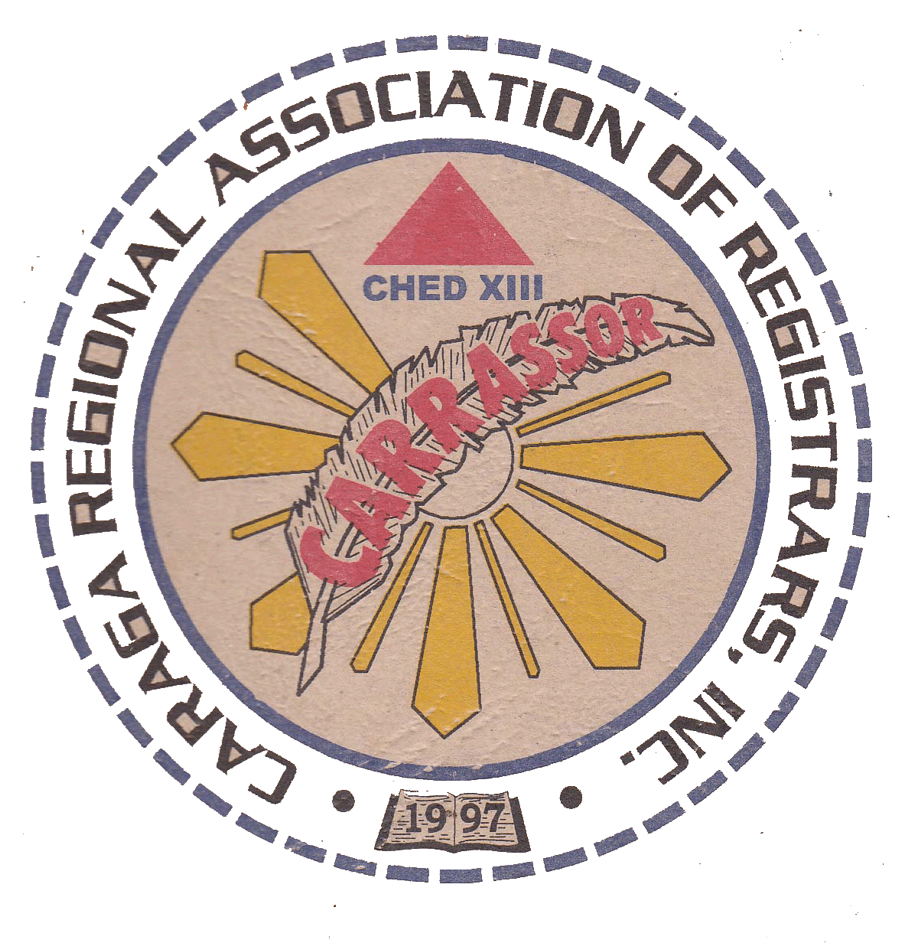**CARAGA REGIONAL ASSOCIATION OF REGISTRARS, INC.**

**Caraga Region**

**9th GENERAL ASSEMBLY**December 3-4, 2015

Dotties Place, Butuan City

***Theme: “Registrars: Embracing the Challenges of ASEAN Integration towards Globalization”***

**P r o g r a m m e**

**December 3 (Day 1)**

8:00am - 9:30am **REGISTRATION**

9:30am - 12:00 am **OPENING CEREMONIES**

Invocation SMCC Chorale

National Anthem SMCC Chorale

Dance Presentation SMCC Dance Troupe

Acknowledgement of Participants **Ms. Jocelyn P. Comon**

Secretary, CARRASSOR

Welcome Address **Ms. Claret D. Ruaya**

President, CARRASSOR

Introduction of Keynote Speaker **Ms. Helen P. Medrano**

Vice-President, CARRASSOR

Keynote Address **Dr. Maricar R. Casquejo, CESO III**

Director IV

CHED Caraga

*(Awarding of Plaque of Appreciation to the Keynote Speaker)*

12:00nn – 1:00pm **LUNCH BREAK**

1:00PM – 3:00PM Talk 1 ***“Leading Transformational Change”***

Introduction of Resource Speaker **MS. MAGGIE P. ABULENCIA**

Bus. Manager, CARRASSOR

Message **DR. HAROLD P. PAREJA**

Director II

Civil Service Commission

Agusan del Sur Field Office

*(Awarding of Plaque of Appreciation to the Resource Speaker)*

3:00PM – 5:00PM Talk 2 ***“HEI Accreditation & Bureau of Immigration Updates”***

Introduction of Resource Speaker **MS. ELENA T. AUGIS**

Auditor, CARRASSOR

Message **CESAR ARNEL A. VALDEZ**

Alien Control Officer

Bureau of Immigration

Butuan District Office

*(Awarding of Plaque of Appreciation to the Resource Speaker)*

7:00pm **FELLOWSHIP NIGHT / CARRASSOR’S CHRISTMAS PARTY**

*(Please wear something red and/or green.)*

*(There will be a carolling contest. Contestants will be grouped by province.)*

*(There will be an exchanging of gifts worth P200.00.)*

**December 4 (Day 2)**

6:00am – 6:45am **ZUMBA Session** (*Please wear appropriate attire*)

6:45am – 8:00am **BREAKFAST**

8:00PM – 10:00PM Talk 3 ***“ASEAN Integration for Filipino Professionals & PRC Updates”***

Introduction of Resource Speaker **MS. HILDA S. SANTILLAN**

Board Member, CARRASSOR

Message **JULIE L. sabalza**

OIC, Professional Regulation Commission

Cagayan de Oro Regional Office

*(Awarding of Plaque of Appreciation to the Resource Speaker)*

10:00PM – 12:00PM Talk 4 ***“K-12 Program, Outcome-Based Curriculum, CHED Updates”***

Introduction of Resource Speaker **MS. JEZEL THEA G. FLORES**

Board Member, CARRASSOR

Message **ENGR. RAMIL A. SANCHEZ**

Supervising Education Program Specialist

CHED – Caraga

*(Awarding of Plaque of Appreciation to the Resource Speaker)*

CLOSING REMARKS **MS. MARINESSA D. GONZAGA**

P.I.O. - CARRASSOR

**EMCEE: *MR. TITO P. AMPATER***

12:00nn – 1:00pm **LUNCH BREAK**

1:00PM – 3:00PM **BUSINESS MEETING**

**\*\*\*HOME***SWEET***HOME\*\*\***